Dynamic Nuclear Polarization facilities at the National High Magnetic Field Laboratory

T. Dubroca¹, A.N. Smith², B. Trociewitz¹, A. Akinfaderin⁴, J. van Tol¹, S. Wi¹,
W.W. Brey¹, L. Frydman^{1,5}, S. Hill^{1,4}, J.R.Long^{1,3}

1) NHMFL, Florida State University; 2) Chemistry Dept., University of Florida; 3) Biochemistry Dept.and NHMFL, University of Florida; 4) Physics Dept., Florida State University 5) Chemical Physics Dept., Weizmann Institute

The National High Magnetic Field Laboratory is developing new instrumentation based on Dynamic Nuclear Polarization (DNP) to expand their user program in NMR and MRI/S. DNP has been demonstrated to increase the sensitivity of NMR experiments by several orders of magnitude, which can lead to additional information about the systems being studied and drastically reduce experimental acquisition times. In short, DNP uses microwave radiation to transfer polarization from stable radicals to NMR active nuclei in molecules of interest thereby increasing the number of polarized nuclear spins tremendously and large signal to noise ratios are observed. Three new systems are currently being developed, each specialized for specific types of samples:
1) Dissolution DNP polarizer operating at 5T/140 GHz has been built for in-vivo MRI/S at 4.7 and 11 T.
2) Solid state DNP MAS NMR system is being assembled using primarily commercial components at 14.1 T/395 GHz
3) Solution DNP NMR system is being designed and built to study molecules in solution at 14.1 T/395 GHz.
The dissolution DNP system is installed on the University of Florida campus as part of the AMRIS division of the NHMFL (Figure 1). It has been designed as a platform for both methodology development and in-vivo metabolic studies via MRI/S at both 4.7 and 11 T. The solid state DNP instrument is largely based on the Bruker 600 MHz DNP NMR system and is currently in final development at the Tallahassee site of the NHMFL. This system shares a gyrotron, the 395 GHz microwave source, with the in-house custom-designed solution NMR instrument (Figure 2). In order to build robust high field DNP systems for user applications in an efficient manner, our team has acquired standard components from commercial vendors when available. The remaining components are being designed and manufactured in house or in collaboration with Thomas Keating Ltd. The solid and solution DNP NMR systems are expected to be completed this year.
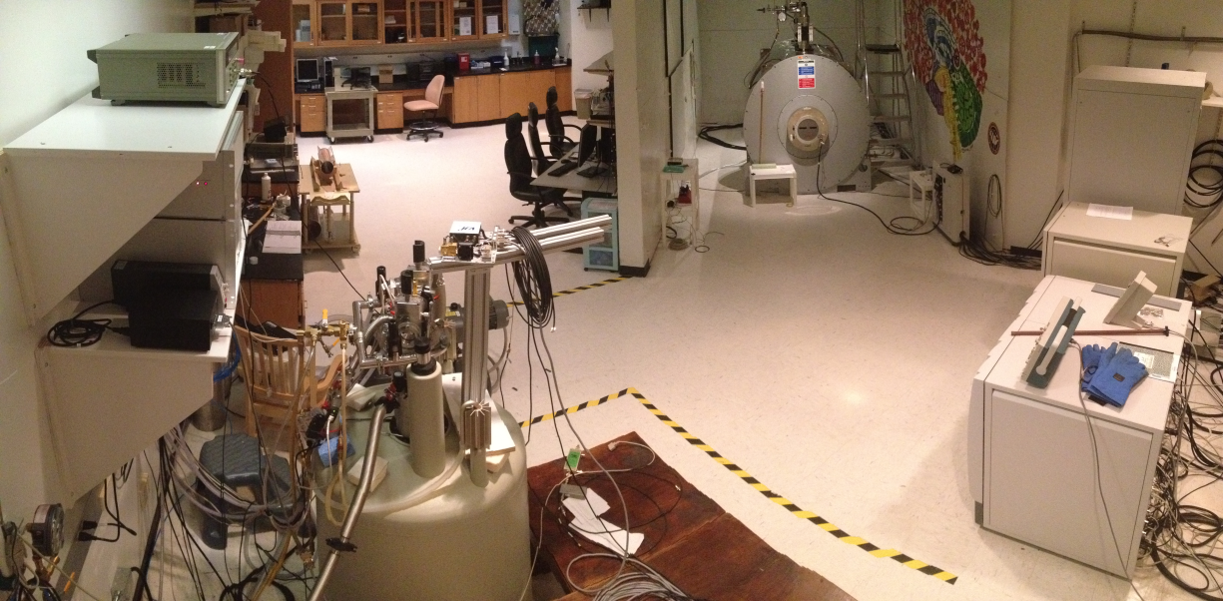
1) Polarizer
home-build
2) Source
140 GHz commercial diode
3) MRI scanner
commercial Agilent 4.7 T
4) Console
commercial - Varian INOVA
5) Transfer line (not shown)
2
1
3
4
Figure 1. Photograph of dissolution DNP system at AMRIS (University of Florida campus).
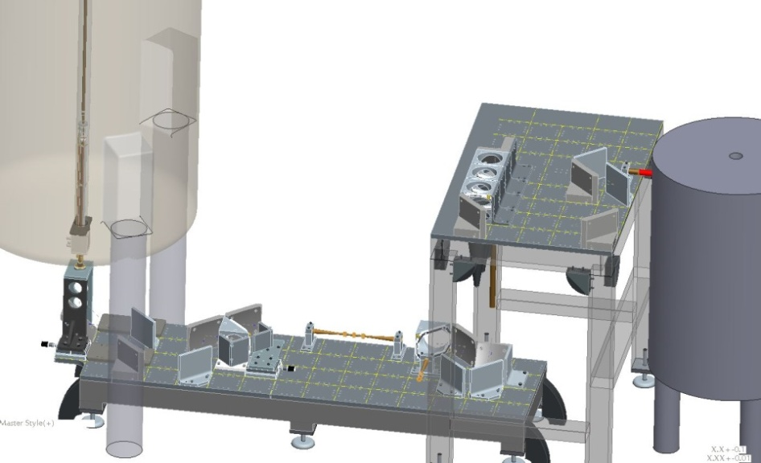
6a
1) Magnet
commercial - Oxford 600 MHz
2) Console (not shown)
commercial - Varian INOVA
3) Probe
in-house modified Varian
4) Sample cavity and holder
in-house design and manufacturing
5) Gyrotron, microwave source
commercial - Bruker 395 GHz
6) Microwave quasi-optics
collaboration with Thomas Keating Ltd
a - power control
b - polarization control
1
3
6b
5
4
Figure 2. Schematic of the quasi-optical table for the solution DNP NMR system (Thomas Keating Ltd.). The solid state DNP magnet (not shown) is located forward and perpendicular to the plane of view.

